2.57: Denote the times, speeds and lengths of the two parts of the trip as t₁ and t₂, v₁ and v₂, and l₁ and l_{2.}

a) The average speed for the whole trip is

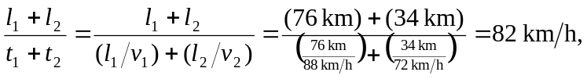

or 82.3 km/h, keeping an extra significant figure.

b) Assuming nearly straight-line motion (a common feature of Nebraska highways), the total distance traveled is l₁–l₂ and

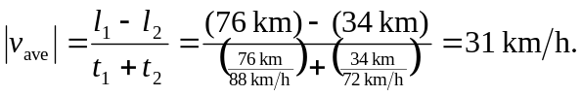

(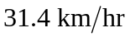to three significant figures.)

